**Developing City Flythrough with Cesium Ion and Unreal Engine 5**

Jason Beal & Alex Pacheco

East Tennessee State University

James Livingston

**Abstract**

This research presents a process for rendering a simulated flight above Chicago using Cesium Ion’s geospatial tilesets rendered using Unreal Engine 5.2 (UE) for use in an immersive experience. Google’s geospatial data offers detailed rendering of Earth's surface suitable for flight simulations, which Cesium parses into discrete tilesets and 3D assets with extra details that further enrich the visual fidelity of particular urban areas. Cesium offers semi-seamless navigation across Earth's surface, barring limitations in flight path customization, sublevel management, and controlling the level of detail (LOD) of various assets. Issues such as grid lines, tile errors, and rural area rendering discrepancies are covered. In addition to the technical constraints of utilizing the software, the topics of recording, presentation, and delivery are also touched upon. Overall, this research provides insights into the strengths and limitations of using Cesium in UE 5.2 for creating immersive flight simulation experiences.

**Developing City Flythrough with Cesium Ion and Unreal Engine 5**

New technologies using geospatial data and efficient rendering optimization have converged to allow users to view the entire globe seamlessly in a real time game environment. This presents numerous opportunities for level design inspired by real world locations, construction planning, expansive open-world gameplay, immersive exhibits, and more. Cesium Ion brings geospatial data from online tools like Google Maps to generate tilesets that include geography, foliage, and other objects around the globe (Cesium, 2023). The Unreal Engine is a real-time game engine that can render these tilesets with 1:1 scale under realistic simulations of natural light. The ability of these powerful technologies to work in harmony is reliant on their proper implementation. Developers need to be aware of the limits of these technologies to optimize the quality of their projects. This research will explore the proper implementation of an immersive rendered environment and examine the limits of these technologies to produce an optimized environment.

**Cesium for Geospatial Visualization**

Cesium is effective for the rendering of the simulated flight in the Unreal Engine of an airplane over the surface of planet Earth by providing realistic land and cityscapes from a reasonable height. Cesium is run through a server called CesiumIonSaaS that stores and streams the geospatial data. This data covers the entire Earth’s surface, but detail is flattened in most areas outside of cities. There are certain areas that include a deeper level of detail including an enhanced street view and other details such as night-time details (Cesium 2023a).

Some areas on Cesium’s Asset Depot include Denver, San Francisco, the Arctic, Melbourne, Montreal, Boston, Washington D.C., and Washington State. These include some enhanced quality on particularly historic buildings (Cesium ion 2023).

**Figure 1**

*Enhanced Models*

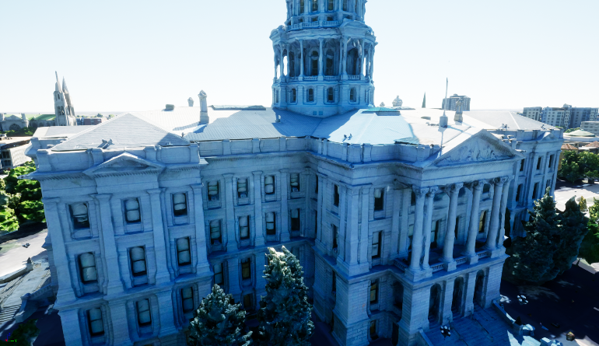

While the exact optimal viewing distance from individual 3D assets varies case by case, the apparent rules of thumb are as follows. Cesium’s generated mesh assets are primarily built from satellite data and thus have the highest detail when seen from above. Of note is a great loss of detail caused by Cesium’s data analysis which causes objects close to the ground to blend, as seen in Figure 2. This also affects objects captured in motion such as cars, objects hidden below other objects, such as beneath awnings and bridges, and large reflective surfaces like shopping windows.

**Figure 2**

Objects merged with the ground.

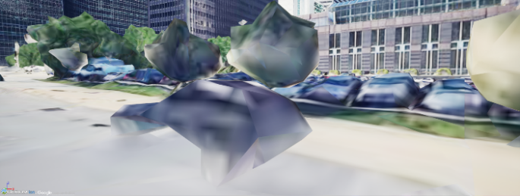

Warping and artifacting are also common at the human eye level. Cesium assets often fail to properly represent relatively thin objects such as lamp poles and street signs, and particularly reflective or emissive objects can result in free-floating artifacts. Finally, even at reasonable altitudes, Cessium generated assets lack a level of close-up detail, as seen in Figure 4. This research recommends Cesium for its cheap, efficient, and easy access to geospatial data. However, while Cesium is certainly good for quick and easy work, the current level of detail offered by this technology is still only suitable to be viewed at an appropriately large distance.

**Figure 3**

Floating Artifacts caused by highly reflective surfaces.

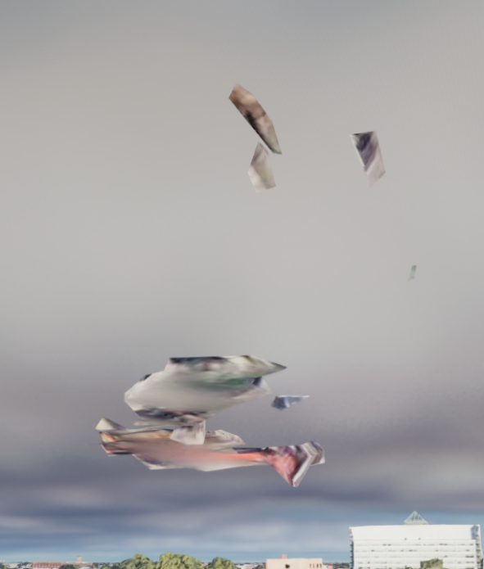

**Figure 4**

Skyscraper closeup LOD

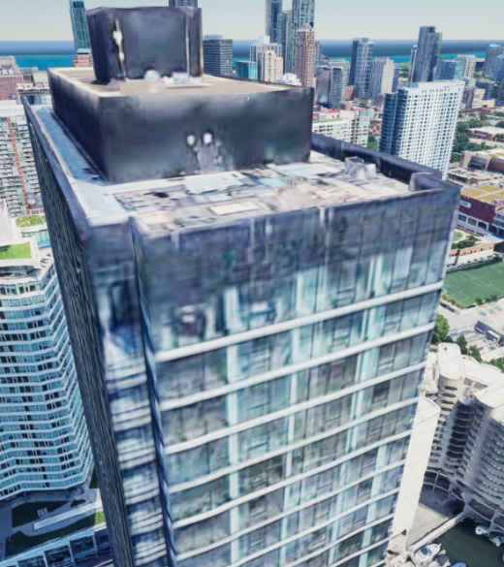

**Cesium Flightpath Scripting**

As an engine primarily for game design, Unreal’s visual assets are arranged and contained in levels. UE allows developers to separate assets within these levels into sublevels, which can be hidden or unhidden to quickly modify the ever present main or persistent level. Adding guide assets to a sublevel allows quick swaps between areas of the globe with the ‘CesiumFlyTo’ component attached to the system’s default user controller, the DynamicPawn. Unfortunately, added assets may cause shadows to be cast on the opposite side of Cesium geometry (Cesium 2023b). It is possible with the help of blueprints to manually switch between different vehicle pawns as they traverse the map (BiMaking Engineering 2023).

**Figure 5**

Shadow error on added assets

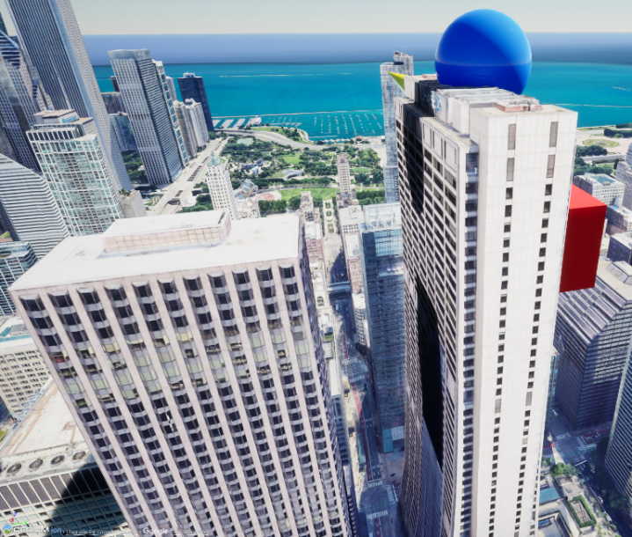

Alternatively, the user can customize their flight path among curves between global points to traverse smoothly with blueprints. “Fly to Location Longitude Latitude Height” requires floats input for pitch and yaw, a vector for longitude, latitude, and height at the destination, a target “Fly To” component, and booleans for “can interrupt by moving”, “Fly to Location Unreal”, and “Interrupt Flight”. Curve objects can be made to customize the flight path, duration, and transitions. In the context of a flight simulator, this can give the user a variety of options to traverse to intricately detailed city scenes that they can explore and jump between at will (Montieri 2022).

**Google Photorealistic 3D Tiles**

Google Photorealistic 3D Tiles can allow someone to navigate anywhere on Earth, but scale poses an issue. This research found the optimal adjustment to navigate the Earth during editing was to scale the camera speed in the viewport to its maximum and set the camera speed scale at 7x. Once a user is close to the specific region that they would like to view closer, they can reduce the scale gradually down to 1 depending on range. This is preferable to scaling down the size of the Earth due to a visual glitch that shows grid lines and objects which obscure the camera view. When scaled, there is no noticeable difference in the quality of the details.

**Figure 6**

Visible grid lines over city

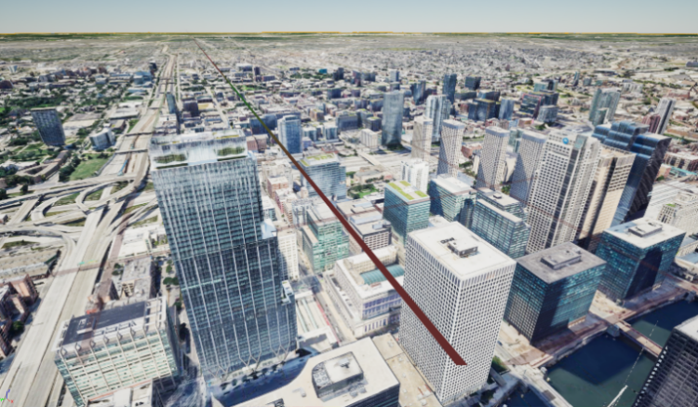

The planet’s surface will appear slanted further away from the level georeferenced origin point. This can be corrected by hitting the ‘Place Georeference origin here’ button in the settings panel with ‘Google Photorealistic 3D Tiles’ selected. Errors occasionally occur on the map where a tile will be transparent (Cesium 2023c).

**Figure 7**

*Tile Error*

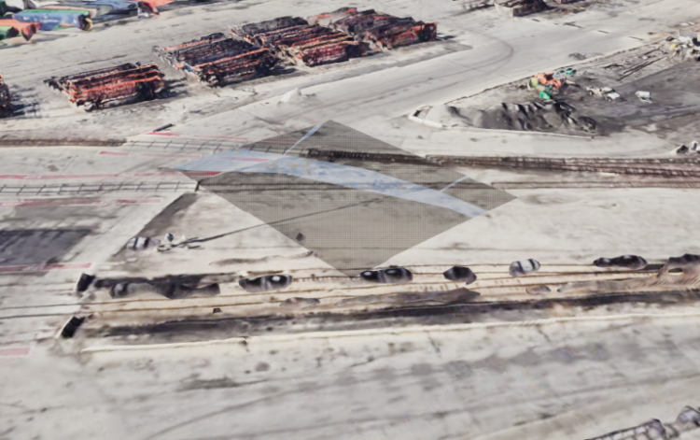

Highly populated areas have 3D building data, rural areas do not. Planning the flightpath of your simulation will be assisted by keeping this in mind to be at a significant height by the time you reach these flattened areas. An alternative to this would be covering the flattened images with appropriate models.

**Figure 8**

Flat Rural

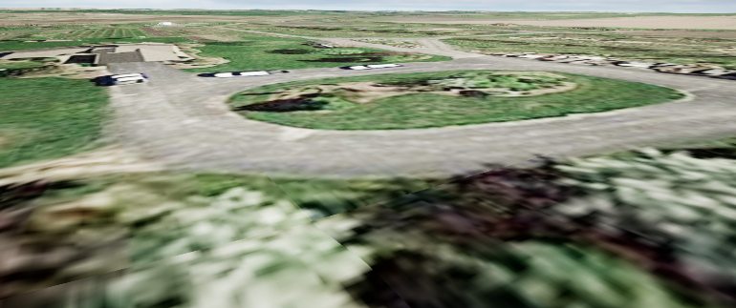

**Managing the Level of Detail**

The level of detail is dependent on the setting for Maximum Screen Space Error in the ‘Google Photorealistic 3D Tiles’ settings. Setting this too low or too high both have drawbacks. The lower the setting is, the more detail you will get on the areas further away from the camera. This is a memory limitation and all areas outside of the view of the camera are culled by default. With this setting, it can cause the models and textures to ‘pop in’ as they load when you rotate the camera. A higher setting can quicken the time it takes to load in details but you will lose details far away from the camera. Depending on the user’s hardware, numbers as low as 2 can cause the engine to crash based on memory limitations. Research found a setting of 4 had a load time of roughly 60 seconds when turning the camera in the dense urban environment of downtown Chicago. At a setting of 64, there were no visible loading details.

**Figure 9**

*Maximum Screen Space Error Settings 4, 64*

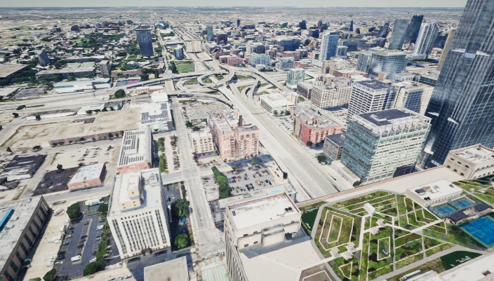

*Note.* Level of Detail far from the camera degrades as the MSSE setting is set higher

Enforce Culled Screen Space Error’ is a boolean setting that allows for the selective culling of tiles outside the frustrum of the camera or hidden in fog. This can be useful for maintaining physics and shadows on objects outside of the frustrum at the cost of consuming more resources. The culling of tiles obscured by fog can be enabled or disabled by the boolean setting: ‘Enable Fog Cull’. ‘Forbid Holes’ is a boolean setting that will restrict the engine from loading a child tile that has not been loaded yet and will revert to its parent tile instead of leaving a blank spot in the area. This can improve performance but causes details to pop in. The setting for ‘Maximum Cached Bytes’ is a setting that determines when tiles that are not necessary for loading will be unloaded. The boolean setting ‘Enable Frustrum Culling’ could be useful for a more consistent physics simulation. ‘Enable Occlusion Culling’ is a boolean setting that could increase performance in areas with a large amount of occlusion but unnecessary overhead in areas that do not. The ‘Occlusion Pool Size’ determines the number of components to use during the occlusion query. ‘Delay Refinement for Occlusion’ can cause some delays before tiles appear but improve performance costs due to avoiding load of occluded descendants. ‘Create Physics Meshes’ is a boolean setting that can improve performance when disabled if any actors will not collide with objects in the scene (Cesium 2023a).

**Cesium Sunsky**

A tool is included with Cesium that applies natural light in the scene. Similarly to global lighting, Cesium Sunsky can be rotated to affect the time of day. However, some light flickering will occur during times at dusk and early morning.

**Figure 10**

*Dusk Flickering*

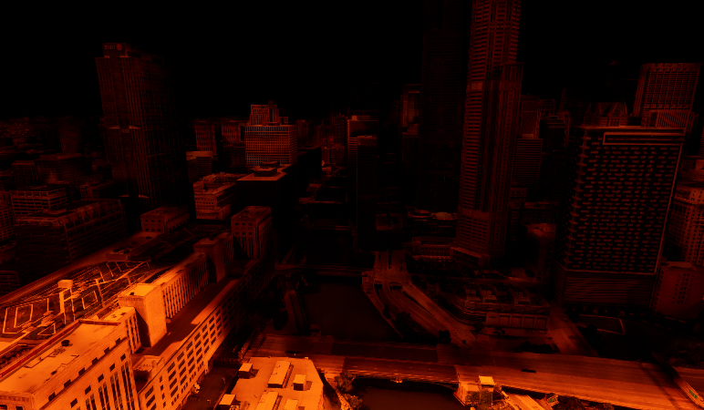

**Cesium Georeference** -

The latitude and longitude of locations on Earth can be input here to jump to that location. The Georeference is an actor within a Cesium level that relates to the coordinate system for the selected actor. These georeferences are automatically generated if none already exist and can be accessed through blueprints using “Get Georeference”. “Apply DPI Scaling” is an option for high DPI screens and mobile devices to improve performance. Rotation (East-South-Up) - Use Roll to adjust Sun position (time of day) - Give some time for light to populate. Sunset can cause certain lighting issues. Swapping to daytime will oversaturate with light. Rotate the camera to adjust. The latitude and longitude of locations on Earth can be input here to jump to that location (Cesium 2023d).

**Cloud Generation**

Unreal has a robust system for generating volumetric clouds. This system has general settings that include the “Layer Bottom Altitude” that determines the distance from the ground that the system will begin drawing clouds. It will then draw clouds for the distance determined by “Layer Height”. However, far more control can be applied through the material created for the clouds and that is where more complications can arise. The material includes a specialty node called “Volumetric Advanced Output” that has options that affect phase and multiscattering. To give the clouds some movement, a time node can be used to add to a wind direction value that can include both the direction and speed applied to the UVs for extinction. This is added through a “Constant4Vector” that multiplies the red and green channels to a time node that gives them a 2-dimensional direction to travel in and the blue channel can be multiplied after to apply cloud speed. Cloud movement can cause non-synchronous renders to be misaligned with each other.

**Figure 11**

*Clouds*

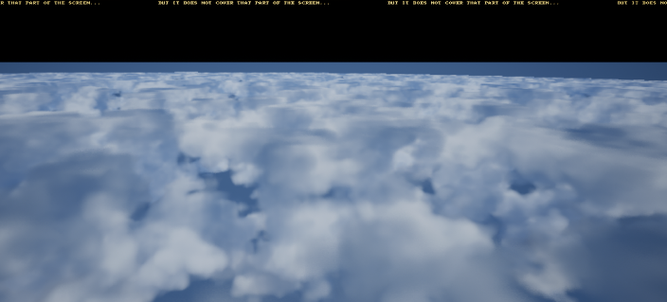

For this research, the cloud movement was disabled and a “TexCoord” was added to art direct the location of the clouds. The extinction property originally caused chromatic artifacts around the edges of the clouds that can be removed by masking the blue channel. A parameter, “Height Bias”, was used in conjunction with Cloud Sample Attributes. Some issues that can arise is the top of the clouds becoming noticeably flattened by the top of the volume, the skydome not covering the area above the clouds, and cloud placement (Metaverse TechArt 2022).

**Initial Considerations for Implementation**

Alongside the categorization of the functionality and technical errors present in the software, a portion of this research is dedicated to the construction of a theoretical exhibit utilizing Cesium and Unreal. The original form of the proposed exhibition involves a viewer surrounded with a number of synchronized monitors, each playing a different perspective during a virtual flythrough. The synchronized videos would be rendered from UE 5.2, with Chicago reproduced through geospatial data from Google Earth and Cesium Ion (Cesium GS, 2023b).

**Figure 12**

*Chicago in Unreal using Cesium*



**Figure 13**

Proposed initial exhibit layout

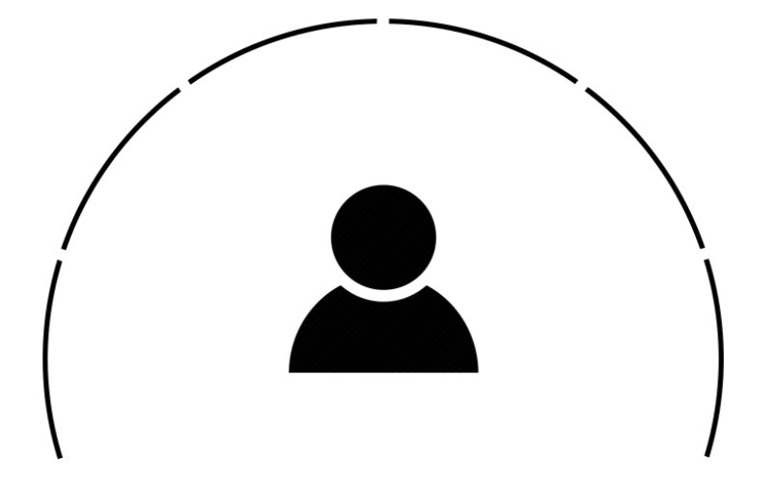

The intent behind such an exhibit would be to immerse the viewer in the virtual scene, with perspectives similar to an aircraft cockpit or passenger windows. The exact structure of the proposed exhibit varied throughout the development process, with three, five, and six monitor variants. It was also proposed for screens to be spread out to spatially mimic the interior of commercial passenger aircraft, with substantial gaps between screens.

Many of these layouts were structured based on the Airbus A32 (Airbus 2021), a passenger airliner with a well-documented interior. However, while this research originally intended to simulate such a perspective, consideration for presenting the aircraft interior and matching window sizes to screen resolutions inevitably led to the abandonment of this concept for the scale of the accompanying project.

While the stylistic concept fell through, the structural layout remained as the foundation for practical presentation. This led to the development of the CamActor, a collection of virtual cameras and their respective rig, designed to capture short videos. Each of the five cameras renders its own perspective into a video file to be played on its respective monitor.

**Figure 14**

*The CamActor*

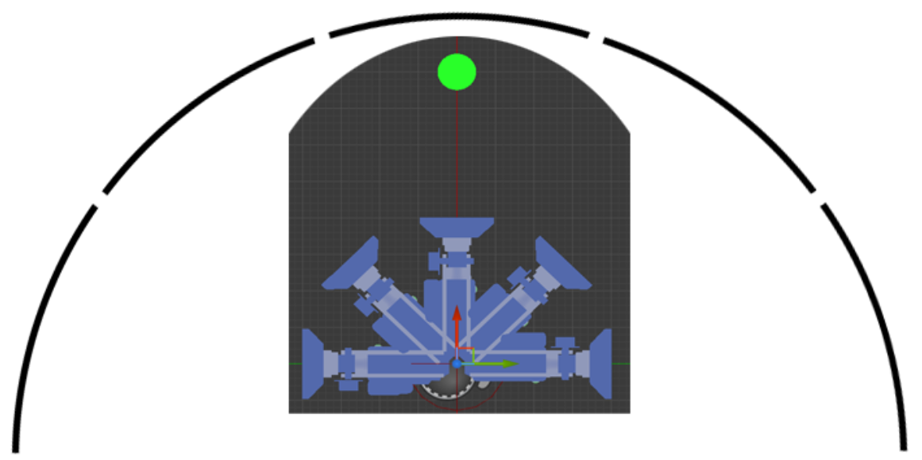

The CamActor replaces the DynamicPawn as the default user controller so its actions can be precisely controlled without introducing guide objects and glitched shadows. For this purpose, a spline path is lain out over the city to function as a dolly as shown in Figure 15. The camera follows the path at a variable speed controlled by a timeline, over a predetermined duration to prevent jitters in motion. However, since the spline is a three-dimensional Bezier curve, the cameras default to matching the orientation of the path, essentially performing accidental barrel rolls as the path curves, dips and ascends.

While this a mathematically accurate behavior, it fails to meet the expectation of a stable flight and is incredibly disorienting. To compensate for this, slightly ahead of the cameras is the aim target, represented by the green circle in Figure 14. The camera rig is constantly oriented based on the position of the target, generally perpendicular to the ground beneath. The relationship between the control of the cameras’ orientation and the target’s position is directly proportional to the distance between them. However, as they currently both move along the same trajectory, the distance is kept to a minimum to ensure the camera rig follows the path precisely. Future implementations of this system will have a separate path for the target, which will allow for finer control, and more accurate flight simulation.

**Figure 15**

*Spline path over Chicago, shown in red*

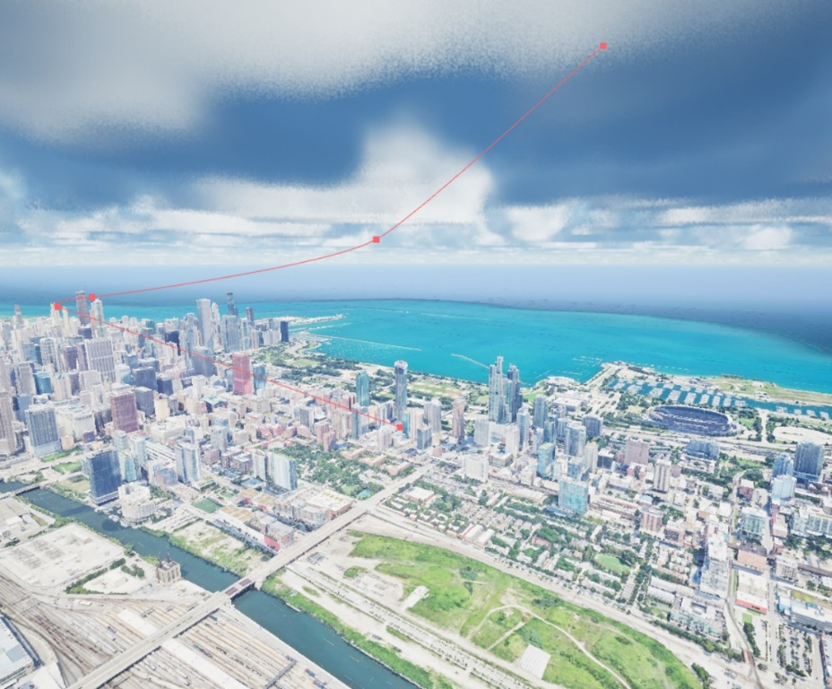

**Rendering Cesium Tilesets with the Unreal Movie Render Queue**

Once the camera rig was assembled, multiple tests were run to optimize the output video. For the purposes of this project, video clips were kept to a maximum length of 10 seconds at 30 fps for a total of 300 frames per test. While this may seem like a short output in the context of a practical exhibit, it should be noted that these short clips are precursors to a more complete product, and that the repetitive nature of testing optimizations necessitated shorter outputs.

The first barrier to accurately render with Cesium is forcing the correct tilesets to load. Within Unreal, Cesium’s photorealistic Earth recreation is contained entirely within a single level, so constraining the renderable area is a must. Luckily, this is easily done by creating a sequencer object referencing the CamActor within the level, and overwriting the default camera settings within the level’s blueprint. However, referencing the camera in this way causes an undesirable side effect. Rather than rendering the preloaded default tileset, Cesium is forced render the previously unloaded, desired tileset. This yields one of two results, unloaded, low LOD assets, see Figure 16, or phantom frames in which portions of the cityscape render as semi-transparent, see Figure 17.

**Figure 16**

*Frame with low LOD*

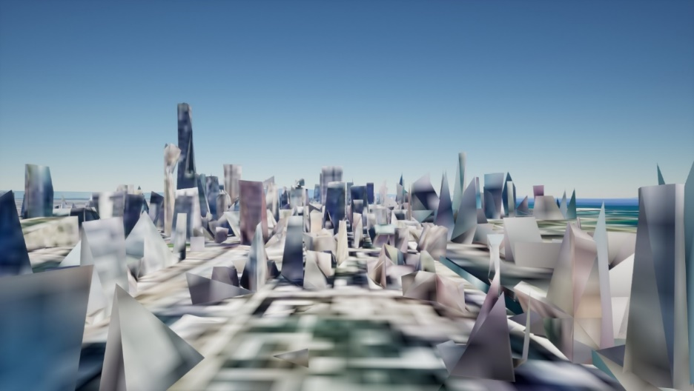

**Figure 17**

*Phantom frame*



In order to prevent these errors, the tileset’s screen space error was lowered substantially and frustrum culling was enforced, as mentioned in a previous section. However, while these changes greatly increased the overall render quality after the first 50 frames on average, the initial frames continued to show errors. This was resolved by switching from UE 5’s simple render settings interface to its advanced Movie Render Queue controls. The most notable difference between the two control schemes is the queue’s ability to save sets of settings into individual files, which allowed for an iterative workflow. The final resolution to improve the initial frames was providing a delay between launching the render engine and capturing frames. Within the render queue’s anti-alias settings, the engine was set to have 1800 warm up frames to fully load the level before beginning to render.

**Resolving Multi-Display Presentation**

Controlling and synchronizing the videos across multiple screens is difficult without the appropriate tools. The proper tools are a mix of hardware and software which are proposed as follows. The software solution originates in the field of digital signage. Synchronized displays are commonly used in airports, malls, and other commercial areas to show advertisements across a large space. These displays are connected to a central network and controlled by a primary computer through a program. Popular contenders for such a program include ViewNeo (Adversign) and MySignagePortal. The hardware solution is a video wall controller. Where a video splitter would allow a single video input to duplicate to multiple screens, wall controllers allow single videos to be spanned across multiple displays (Billias 2023). To achieve a video wall that partially surrounds the viewer however, the various videos must be cut, stitched, and otherwise edited to fit the composite screen. This research proceeded using Visibox (Billias 2021), a software designed for controlling graphics during concert performances in place of the previously mentioned signage software because of its simplicity and availability.

In addition, the nature of the exhibit brought forth a potential alternative to multi-screen displays by enforcing an interactive perspective through panoramic rendering. Similar effects have been achieved by Ideum and shown in the Smithsonian, giving credence to the method (Spadaccini, 2018). Unreal Engine’s panoramic render setting is currently still in beta, but can be accessed from the advanced render queue settings (Winbush, 2022). Utilizing panoramic rendering caused two notable errors. First is a notable drop in quality due to previous resolution settings, formerly tested at 2048*1080 and 1920*1080. After further testing, 4k resolutions yield good results at about a frame per minute following the load time, but cause a harsh horizon line and harsh artifacting as seen in Figure 19. 8k resolutions resolve this error, but take approximately 4 minutes longer per frame.

**Figure 18**

*Individual immersed in panorma of Peru (Spadaccini, 2018).*

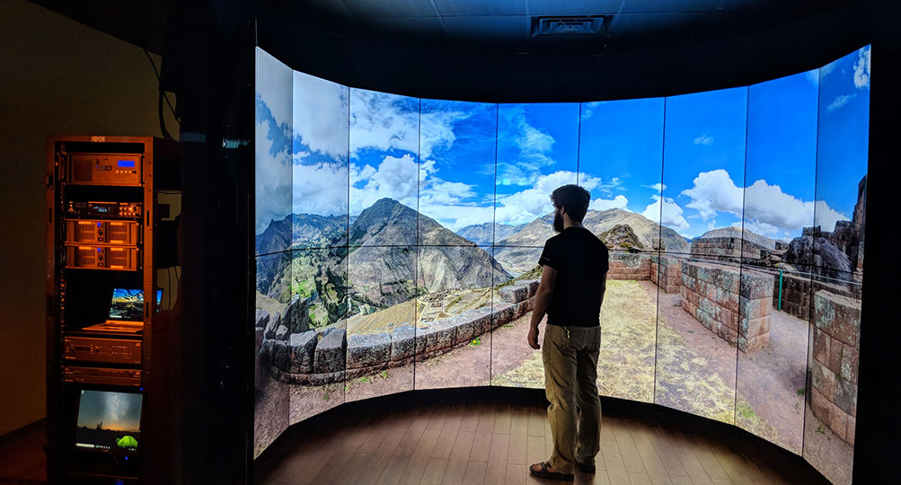

**Figure 19**

*Section of 4k vs 8k panoramic renders*



The second error which occurred upon switching to panoramic rendering is a reoccurrence of the LOD drops. This is likely due to the change in the CamActor’s field of view. After another round of tests, the original 1800 loading frames were extended to a total of 9000 loading frames. In other words, the loading time was extended from one minute to five minutes per test. This five minute loading period was found to be the most efficient way of preventing LOD drops for all subsequent renders. As mentioned previously however, the panoramic renderer is in beta and is prone to one particular error that this research fails to account for. Unpredictably, the camera may rip a frame, as shown in Figure 20. When compiled, the rips will result in holes and warps at the top and bottom of the finished video. Currently, research suggests that these frames can be re-rendered separately, but given the previously mentioned 5 minute loads, this is not an efficient solution. Further research into preventing these tears should be explored.

**Figure 20**

*Unripped vs ripped panoramic frame*

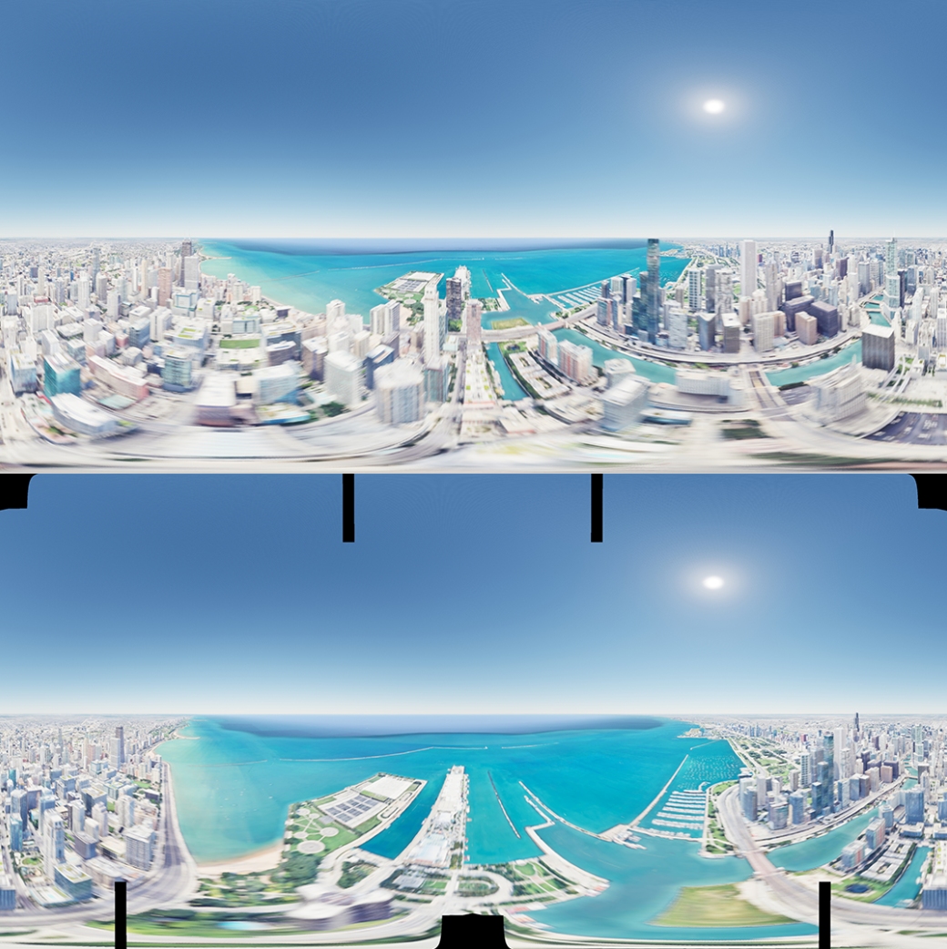

**Conclusion**

Cesium and Unreal Engine are significant tools that can be used effectively for immersive flight simulations, provided an understanding of the strengths and limitations of each platform. Cesium offers many tools and settings to resolve, mitigate, or avoid issues such as reflective surfaces, tiling, and shadow errors that may affect rendering quality, particularly at lower altitudes. However, this research suggests the use of appropriate external assets to optimize objects requiring higher detail, clouds and foliage. Continued advancements in geospatial rendering technologies offer promising opportunities for creating immersive and realistic virtual environments in Unreal Engine, catering to diverse simulation needs and enhancing user experiences. In addition, although Unreal Engine’s virtual panoramic rendering is currently in beta, it is a powerful tool that can serve as an alternative for more complex and traditional multi-display presentations.

**References**

Adversign Media GmbH. (n.d.). *Screen sync plugin: Efficient and practical*. viewneo. https://www.viewneo.com/digital-signage-software/viewneo-plugins/viewneo-screen-sync-plugin

Airbus. (2021). *A320 Cabin*. https://www.airbus.com/en/products-services/commercial-aircraft/cabin-and-comfort/welcome-to-airspace-cabin/a320-cabin

Arturo Montieri. (2022, May 5). *My Little Flight Simulator* [Video]. YouTube. https://www.youtube.com/watch?v=FrBHjG5C2NQ&list=PLda3EyUkAB7iygn_83xUL4CaNtc4T8sno

Billias, A. (2021). *Visibox*. Spaceage. https://spaceage.tv/

Billias, A. (2023, November 14). *Play a single video across multiple screens*. YouTube. https://www.youtube.com/watch?v=nRYVsOXNQk0&ab_channel=Spaceage

BiMaking Engineering. (2023, May 17). *New Orleans USA, Google Maps Tiles Cesium Unreal - Digital Twin Tour in Metaverse | 2023 UE5.2* [Video]. YouTube. https://www.youtube.com/watch?v=oC1kcBSari0&list=PL0FM467k5KSzKnGvp2QS1ss0_zdCqc2Ak&index=8

Cesium GS.(2023a). *Photorealistic 3D Tiles from Google Maps Platform in Cesium for Unreal*. https://cesium.com/learn/unreal/unreal-photorealistic-3d-tiles/

Cesium GS.(2023b). *Build a Flight Tracker with Cesium for Unreal.* <https://cesium.com/learn/unreal/unreal-flight-tracker/>

Cesium GS.(2023c). *Cesium for Unreal Quickstart.* <https://cesium.com/learn/unreal/unreal-quickstart/>

Cesium GS.(2023d). *Using a Geospatial Accurate Sun.* https://cesium.com/learn/unreal/unreal-geospatially-accurate-sun/

Cesium ion.(2023). *Asset Depot*. https://ion.cesium.com/assetdepot/354307

Metaverse TechArt. (2022, September 11). *Volumetric Clouds & Sky Effects PART01 : Clouds base shape*. YouTube. https://www.youtube.com/watch?v=paO-Its5P2Q&list=PLIxJB8bm2Y11ZX8oCMZQxtX4Nx_0kmwj3

Spadaccini, J. (2018, February 16). *Sneak Peek: Immersive video wall*. Ideum. https://ideum.com/news/sneak-peek-immersive-video-wall

Winbush, J. (2022b, July 29). *Unreal engine 5 360 panoramic easy! | no coding no plugins*. YouTube. https://www.youtube.com/watch?v=SpkP1XCF_mE&ab_channel=WINBUSH

Worstplayer. (2022, Jun 29). *UE5 EasyFlightModel+Cesium tutorial* [Video]. YouTube. https://www.youtube.com/watch?v=pMpvvxh-UZ8